**SALES PERFORMANCE DASHBOARD**

**SUBMITTED BY,**

**AARATI VENUGOPAL NAIR**

**INTRODUCTION OF SALES PERFORMANCE DASHBOARD**

A sales performance dashboard is a powerful tool which helps to design a comprehensive overview of an organization sales activities and outcomes. In today’s data-driven business environment, having immediate access to key sales metrics is essential for informed decision-making and strategic planning. It can help users to identify trends, make data driven decision gain insight into sales performance. A sales dashboard in Power BI is a visual representation of sales data that allows you to analyze and monitor sales performance.

**ABSTRACT OF SALES PERFORMANE DASHBOARD**

A sales performance dashboard is an analytical tool designed to give a overview of an organization’s sales metrics, enabling stakeholders to make informed decisions based on data-driven insights. This dashboard integrates key performance indicators (KPIs) such as revenue trends, sales by region, and top-selling products, facilitating a comprehensive analysis of sales performance over time. By employing interactive visualizations, including line charts, bar charts, and pie charts, the dashboard allows users to easily explore and interpret complex data sets. The primary goal of the Sales Performance Dashboard is to enhance visibility into sales dynamics, empowering sales teams and management to identify strengths and weaknesses within their operations.

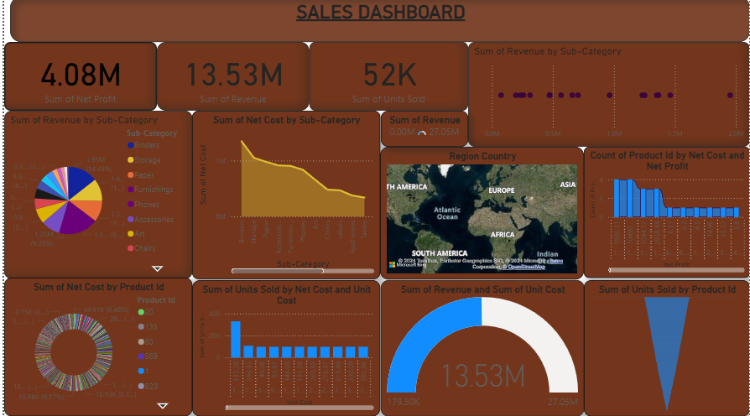

CONCLUSION

As a conclusion This dashboard plays a critical role in improving sales forecasting, resource allocation, and operational efficiency, ensuring that sales strategies are aligned with business objectives and market demands. By leveraging this tool, sales teams can better understand their performance, optimize their approach, and ultimately drive revenue growth.